Ideation Phase
Define the Problem Statements

Date | 28 SEPTEMBER 2026
Team ID | 6ab220cfbee0b08a2d2c63cd
Project Name | Auto Ticket Classification using FLOW DESIGNER
Maximum Marks | 2 Marks

Customer Problem Statement
Core Problem:
The school IT helpdesk receives multiple incident requests daily (such as Wi-Fi issues, projector failures, password problems, and slow computers), but manual categorization by IT staff is time-consuming and inefficient.
Proposed Solution:
Automate ticket classification and routing using ServiceNow Flow Designer by analyzing keywords in the short description and description fields.
Manual Effort:
Currently, IT staff manually reviews each request and assigns a category and subcategory, which is inefficient.
Inefficiency:
This manual process is time-consuming, prone to human errors, and reduces the overall speed and responsiveness of the helpdesk service.

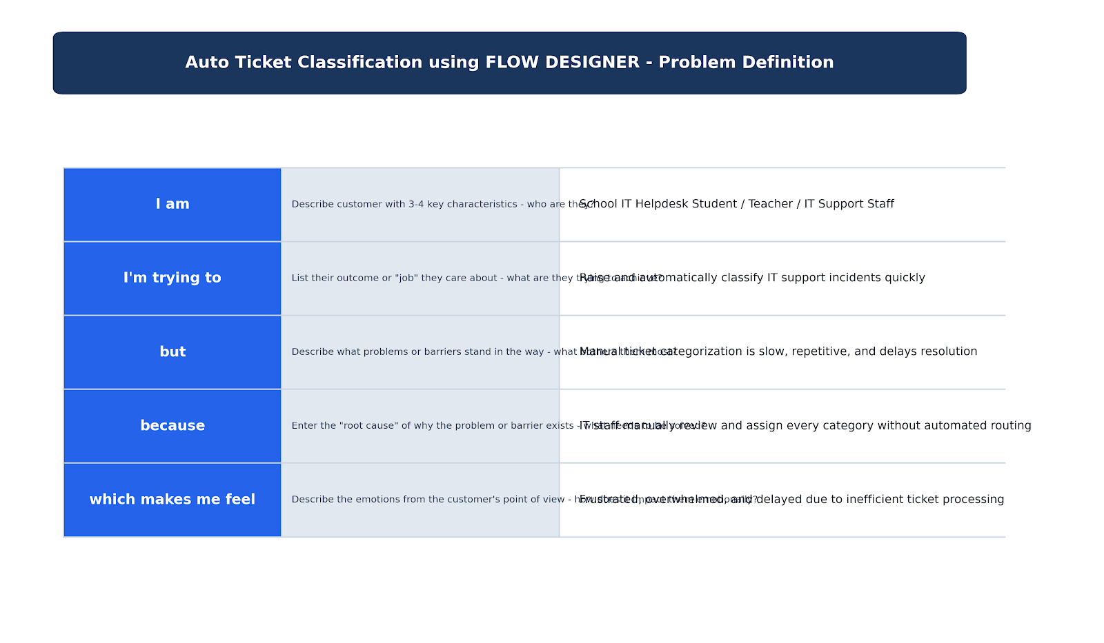Example:
Problem Statement 1 (PS-1)
- I am (Customer): Student / Teacher
- I'm trying to: Raise an IT support request for everyday issues (Wi-Fi, Projector, Password)
- But: Manual categorization by support staff is slow and causes delays
- Because: IT agents review each ticket manually without automated routing
- Which makes me feel: Frustrated & Delayed
Problem Statement 2 (PS-2)
- I am (Customer): IT Support Staff
- I'm trying to: Process a high volume of helpdesk tickets efficiently
- But: Too many incoming tickets take excessive time to sort and categorize
- Because: There is no automated keyword-based classification system in place
- Which makes me feel: Overwhelmed & Inefficient

